KEPM -

Background
You can have values calculated automatically in costing-based CO-PA. This procedure is called "valuation " and can be used for both planning data and actual data.
Valuation could be achieved in four ways:
- Using material costing
- Using conditions and a costing sheet
- Transfer prices

For Production Companies, valuation is be possible by the cost component structure available, where this information will not be available for non-production companies due to the fact of not having material cost estimates for the products.

The result of the valuation is a breakdown of (Material, Fixed, Variable, Depreciation, Indirect Overhead Costs).

Scenario
Plan for Revenue 10000000 and Sales Qty 90 for customer 1000 – HQ (Stock Value/Variable/Fixed /Depreciation/Indirect Overhead Costs) will be valuated.

Prerequisites
You specify in Customizing for CO-PA valuation what is to form the basis for the valuation.

Menu Path | Accounting → Controlling → Profitability Analysis → Planning → KEPM - Edit Planning Data
Transaction Code | KEPM

1. Double click on KEPM - Edit Planning Data.
Planning Framework: Overview

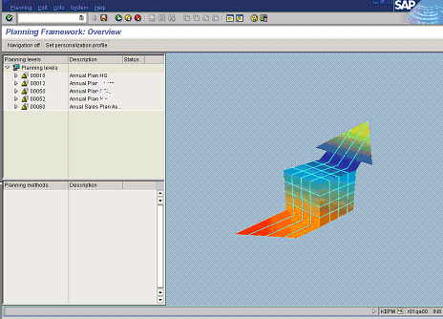

2. Click the Annual Plan tree node to explode the structure.

Planning Framework: Overview

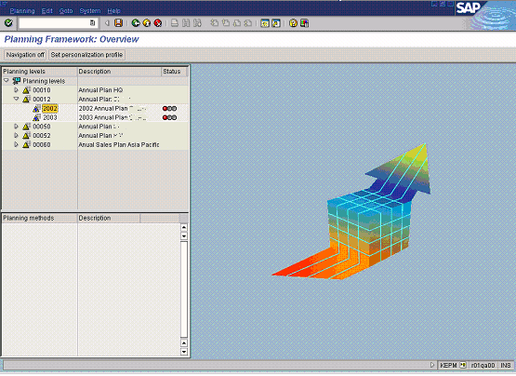

3. Double click on the 2002 Annual Plan tree node to display planning methods.

Planning Framework: Overview

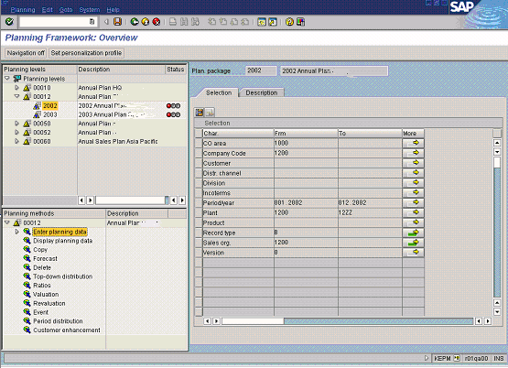

4. Click the Enter planning data tree node to explode the structure.

Planning Framework: Overview

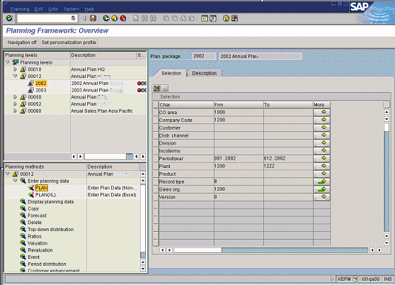

5. Double click on the PLAN tree node.

Change Sales and Profit Plan: Aggregated Values

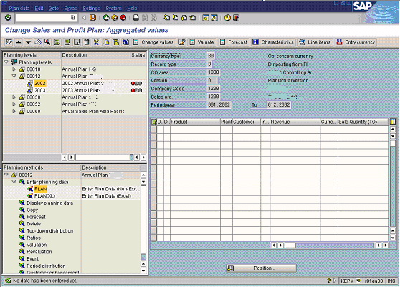

6. Click the Next combination button twice times to reach the combination with record type ‘F’.

7. Press the ‘F8’ function button on your keyboard to turn off Navigation Screen.

Change Sales and Profit Plan: Aggregated Values

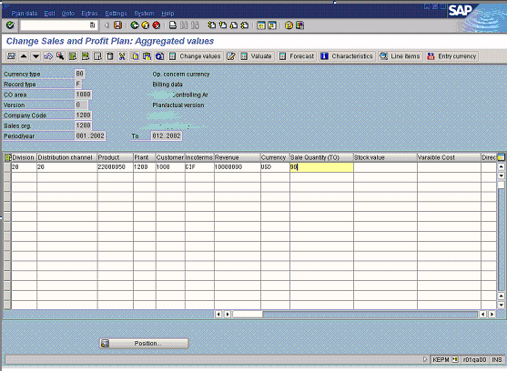
8. Update the following fields:

Field Name | Field Description | Values
Division | The way of grouping materials. | Example: 20 - Polyolefins
Distribution channel | Distribution channel. | Example: 20 - Wholesales
Product | Key identifying a product. | Example: 22000050 – 318B
Plant | Key identifying a plant. | Example: 1200 - Sharq
Customer | Key identifying a customer. | Example: 1000 – SABIC HQ
Incoterms | Trading terms that comply with the standards established by the International Chamber of Commerce (ICC). | Example: CIF – Costs, Insurance & Freight
Revenue | Planned Revenue | Example: 10 000 000
Currency | Planning Currency | Example: USD
Sale Quantity (TO) | Planned Sales Quantity in Tons | Example: 90
9. Click the Enter button.
Change Sales and Profit Plan: Aggregated Values

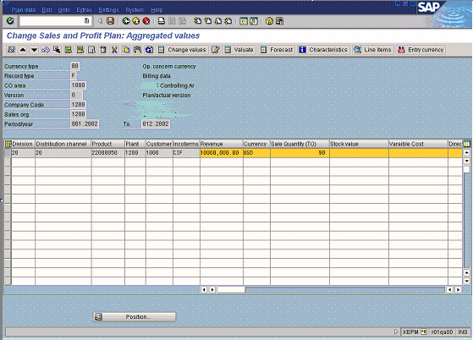

10. Select the line item and click the Valuate button to valuate, i.e. ‘Stock value’ in accordance to sale quantity.

Change Sales and Profit Plan: Aggregated Values

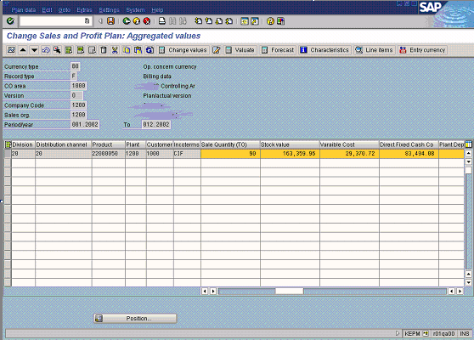
11. Click the Back button.

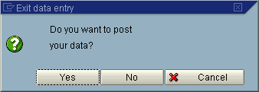

12. Click the Yes button.
13. Plan data was posted with document number ‘XXXXXXX’.

14. Click the Back button to go back to the SAP Easy Access screen.

